
Pizza
Margherita ………………………………………………………………………………………………………………..………..8,00€ A,G
Tomatensoße, Mozzarella
Pomodoro, mozzarella
Tomato sauce, mozzarella cheese
Marinara …………………………………………………………………………………………………………………..……..…….7,00€ A
Tomatensoße, Knoblauch, Oregano
Pomodoro, aglio, origano
Tomato sauce, garlic, oregano
Romana ……………………………………………………………………….………………………………………….………..10,00€ A,G
Tomatensoße, Mozzarella, Sardellen, Kapern
Pomodoro, mozzarella, acciughe, capperi
Tomato sauce, mozzarella cheese, anchovies, capers
Schinken/Prosciutto/Ham ………..……………………………………………………………………………………...10,00€ A,G
Tomatensoße, Mozzarella, Schinken
Pomodoro, mozzarella, prosciutto
Tomato sauce, mozzarella cheese, ham
Schinken & Champignons / Prosciutto & Champignons / Ham & Mushrooms …………………12,00€ A,G
Tomatensoße, Mozzarella, Schinken, Champignons
Pomodoro, mozzarella, prosciutto, Champignons
Tomato sauce, mozzarella cheese, ham, champignons
Capricciosa ……………………………………………………………………………………………………………..….……12,50€ A,G
Tomatensoße, Mozzarella, Champignons, Artischoken, Schinken
Pomodoro, mozzarella, champignons, carciofini, prosciutto
Tomato sauce, mozzarella cheese, mushrooms, artichoke hearts, ham
4 Jahreszeiten / Quattro Stagioni………………………………………………………………………..…………....12,50€ A,G
Tomatensoße, Mozzarella, Champignons, Schinken, Artischoken, Oliven
Pomodoro, mozzarella, champignons, prosciutto, carciofini, olive
Tomato sauce, mozzarella cheese, champignons, ham, artichoke hearts, olives
American Style ……………………………………………..……………………………………………………………..……10,00€ A,G
Tomatensoße, Mozzarella, scharfe Salami
Pomodoro, mozzarella, salame piccante
Tomato sauce, mozzarella cheese, spicy salami
Calzone ……………………………………………………………………………………………………………………….……..12,00€ A,G
Tomatensoße, Mozzarella, Schinken, Champignons
Pomodoro, mozzarella, prosciutto, champignons
Tomato sauce, mozzarella cheese, ham, champignons

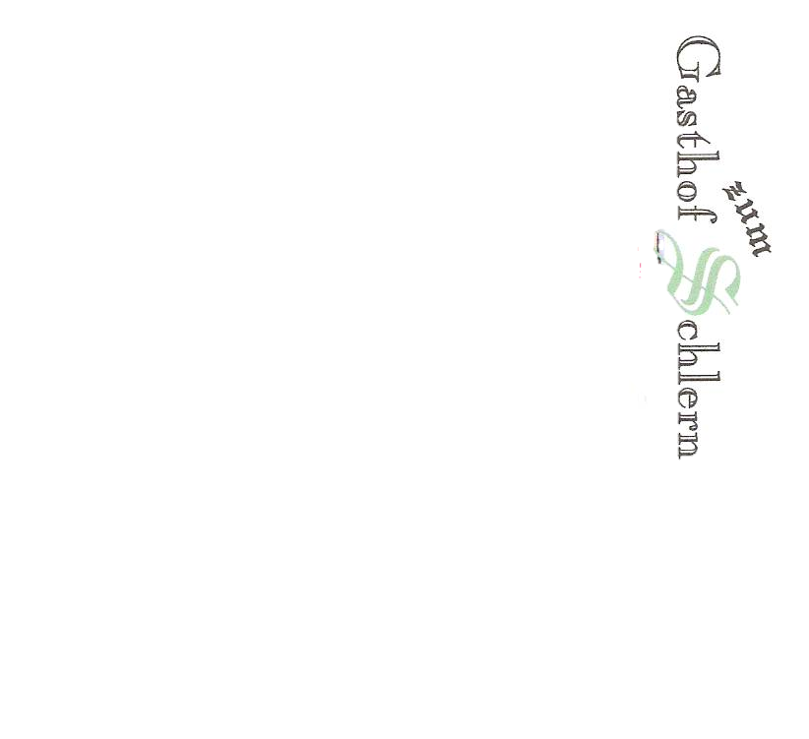
Pizza nur Abends von 17.30 bis 22.00
Pizza solo di sera dalle ore 17.30 alle 22.00
Pizza is served on evenings only,from 5:30 p.m until 10:00 p.m

Brie & Ruccola …………………………………………………………………………………………………………………11,00€ A,G
Tomatensoße, Mozzarella, Brie, Rauke
Pomodoro, mozzarella, brie, rucola
Tomato sauce, mozzarella cheese, brie, arugula
Bauernpizza / Contadina …………………..……………………………………………………………………..……….12,00€ A,G
Tomatensoße, Mozzarella, Speck, Kaminwurzen, Zwiebel
Pomodoro, mozzarella, speck, salamino affumicato, cipolla
Tomato sauce, mozzarella cheese, speck, local salami, onion
Diavola ………………………………………………………………………………………………………………………………11,00€ A,G
Tomatensoße, Mozzarella, Paprikaschoten, scharfe salami
Pomodoro, mozzarella, peperoni, salame piccante
Tomato sauce, mozzarella cheese, peppers, spicy salami
Pizza Chef……………………………………………………………………………………….……………………………..…..12,50€ A,G
Tomatensoße, Mozzarella, Zucchini, Paprika, scharfe Salami
Pomodoro, mozzarella, zucchini, peperonata, salame piccante
Tomato sauce, mozzarella cheese, courgettes, cooked peppers, spicy salami
4 Käsesorten / Quattro Formaggi ………………………………………………………………………………..……12,50€ A,G
Tomatensoße, Mozzarella und 4 verschiedene Käsesorten
Pomodoro, mozzarella e 4 diversi tipi di formaggio
Tomato sauce, mozzarella and 4 different types of cheese
Hawaii …………………………………………………………………………………………………………………….………...11,00€ A,G
Tomatensoße, Mozzarella, Ananas, Schinken
Pomodoro, mozzarella, ananas, prosciutto
Tomato sauce, mozzarella cheese, pineapple, ham
Pizza Rohschinken………………………………………………….…………………………………………………….…….12,50€ A,G
Tomatensoße, Mozzarella, Rohschinken
Pomodoro, mozzarella, Prosciutto crudo
Tomato sauce, mozzarella cheese, cured ham
Rustica…………………………………………………………………………………………………………….………..………12,50€ A,G
Tomatensoße, Mozzarella, Gorgonzola, Rohschinken
Pomodoro, mozzarella, gorgonzola, prosciutto crudo
Tomato sauce, mozzarella cheese, gorgonzola, cured ham
Thunfisch & Zwiebel / Tonno & Cipolla / Tuna & Onion …………………..……………………..….…12,00€ A,G
Tomatensoße, Mozzarella, Thunfisch, Zwiebel, Oregano
Pomodoro, mozzarella, Tonno, cipolla, origano
Tomato sauce, mozzarella cheese, tuna, onion, oregano
Kinderpizza / Margherita per i bambini / Margherita for Kids…………………………………….…..... 7,00€ A,G
Tomatensoße, Mozzarella
Pomodoro, mozzarella
Tomato sauce, mozzarella cheese
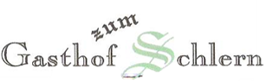
Extras…………………………………………………….……………………………………………………………………………..…..+2,00€
Extra
Extra ingredients
Klein……………………………………………………………………………….…………………..……………………..………...…-1,00€
Piccola
Small

