Kalte Vorspeisen
Antipasti
Hors d’Oeuvres
Tiroler Speck aufgeschnitten mit Brot……………………………………………………………………………….12,00€ A,G
Speck tirolese affettato con pane
Sliced Tyrolean “Speck“ ham with bread
Gemischter Aufschnitt mit Brot……..…………………………………………………………………………….…..13.00€ A,G
Piatto misto di affettati e formaggi con pane
Mixed platter of sliced cold cuts and cheeses with bread
Tiroler Räucherteller mit Brot……………..….…………………………………………….………………………….12,00€ A,G
Affettato mito affumicato alla tirolese con pane
Tyrolean platter of smoked cold cuts ham with bread

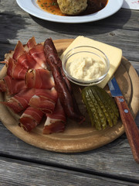
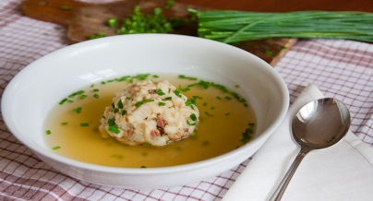
Suppen
Minestre
Soups
Nudelsuppe……………………………………………………………………………………………………………………..…8,00€ A,C,L
Pastina in brodo
Noodles in broth
Tiroler Speckknödelsuppe ……………………………………………………………………………………….……8,00€ A,C,G,L
Canederlo tirolese in brodo con “Speck“
Tyrolean dumpling in broth with “Speck” ham
Milzschnittensuppe ……………………………………………………………………………………………………..…..8,00€ A,C,L
Crostini di milza in brodo
“Pavese” soup
Gulaschsuppe mit Brot …………………………………………………………………………………………………..……9,00€ A,O
Zuppa di gulasch con pane
Goulash soup with bread
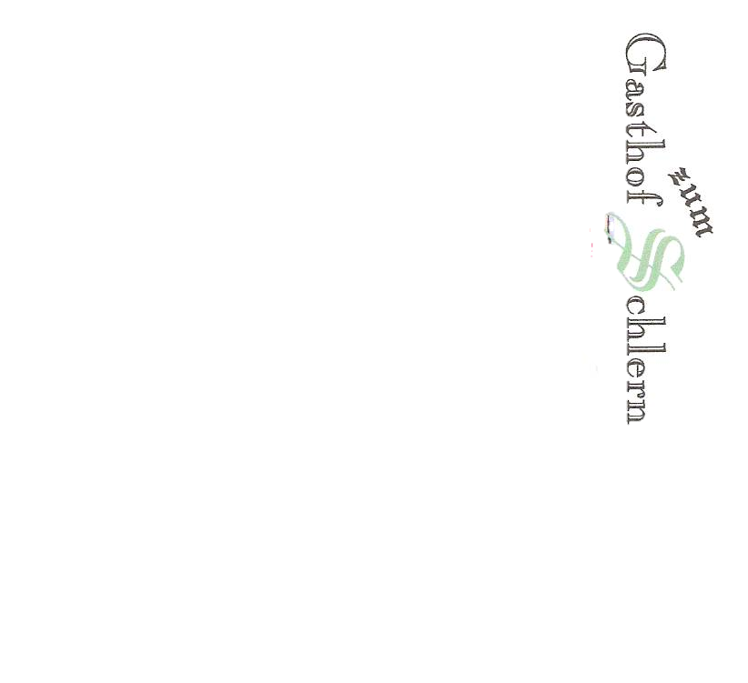
Brot Extra …………………………………………………………………………………………………………………………………2,00€
Pane extra
Bread extra

